KTH Arrival Information

**Terminal 5, Arlanda airport**

This year there will be two official arrival days when representatives of KTH will meet you at Arlanda airport (ARN). The arrival days are August 21st and 22nd. The representatives of KTH will be wearing white t-shirts with a blue/white KTH logo on the front, and a big blue/white ISS logo on the back.   
You will be met at Arlanda airport in **terminal 5’s arrival hall (bottom floor)**. If you arrive in another terminal, please go to **terminal 5**.

Opening hours KTH Accomodation:   
Kista Campus: 2pm - 9:30 pm   
Main Campus (Vallhallavägen): 9:00am - 8pm

**Arlanda airport** 🡪  **Kista**

When going from Arlanda to Kista you will not benefit so much by taking a taxi. Taxi will be slightly faster and the airport coach will not leave very often, but taxi will be more expensive. It would probably cost around 350 SEK for a taxi that can transport 3-4 passengers (if you have a lot of luggage maybe only two persons can share). You can ask the taxi driver how much it will cost. Most (all?) taxi companies have fixed prices when you go to/from Arlanda airport. Different companies might have different prices.

Take the [airport coach (Flygbussarna)](http://www.flygbussarna.se/en/) from Arlanda towards Brommaplan. The airport coach will cost 95 SEK (65 SEK if you can get student discount). It takes about 25-30 minutes. It is 1-2.5 hours between each airport coach to Kista.

Get off at the stop Kista centrum.

The airport coach will stop at the bus terminal below the subway station. The subway station is marked with T in the map.

Follow the green line in the map. Walk straight through Kista Galleria (shopping mall).

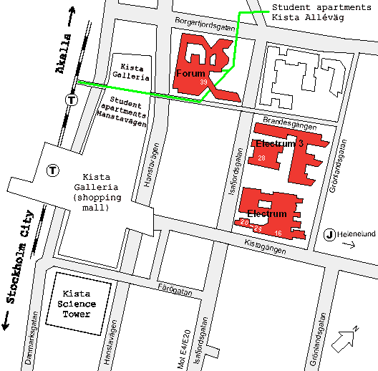

Kista Alléväg 44 A:09b

**Main Campus** 🡪 **Kista**

Take the subway from Tekniska Högskolan (red line) towards Fruängen or Liljeholmen.

Get off at the stop T-centralen (6 minutes).

At T-centralen, change to the blue line subway towards Akalla.

Get off at the stop Kista (17 minutes).

The travel time is about 30 minutes from the subway stop Tekniska Högskolan to the subway stop Kista.

The subway stop has two exits. Choose the exit closest to Akalla (continue to walk in the same direction as the subway you came with). The subway stop is marked with T in the map.

Follow the green line in the map. Walk straight through Kista Galleria (shopping mall).

**Kista** 🡪 **Main Campus**

Take the subway from Kista (blue line) towards Kungsträdgården.

Get off at the stop T-centralen (17 minutes).

At T-centralen, change to the red line subway towards Mörby Centrum.

Get off at the stop Tekniska Högskolan (6 minutes).

The travel time is about 30 minutes from the subway stop Kista to the subway stop Tekniska Högskolan

**Arlanda airport** 🡪 **Main Campus**

The easiest, but most expensive, way to go to Main Campus is by taxi. It would probably cost around 400 SEK for a taxi that can transport 3-4 passengers (if you have a lot of luggage maybe only two persons can share). You can ask the taxi driver how much it will cost. Most (all?) taxi companies have fixed prices when you go to/from Arlanda airport. Different companies might have different prices. Tell the taxi driver that you want to go to KTH Info-Center at Drottning Kristinas väg 4.

Take the [airport coach (Flygbussarna)](http://www.flygbussarna.se/en/) to Stockholm city (Cityterminalen). The airport coach will cost 95 SEK (65 SEK if you can get student discount). It takes about 40 minutes. The airport coach will leave every 10 minutes.

You can also go from Arlanda to Stockholm city by the train [Arlanda Express](http://www.arlandaexpress.com/%20). It takes only 20 minutes, but it is more expensive. Arlanda Express will leave every 15 minutes.

In Stockholm city, take the red line subway towards Mörby Centrum.

In Cityterminalen you can go to Pressbyrån to buy transportation card or coupons.

For information about different tickets, have a look in the official forums: <http://www.ths.kth.se/issforum>

You can recognize subway stations by the T-sign. (T for tunnelbana.)

Get off at the stop Tekniska Högskolan (6 minutes).

Choose the right exit from the subway (green T in the map).

―――――――――――――――――――――――――――――――――――――――

注册的相关信息

**Arrival details**  
Please remember to **register your arrival details** at <http://www.webforum.com/form/kthinternational/form.asp?sid=627211891>.  
The **Information folder**  - "The Blue Folder" (which Karin Knutsson informed you about in her e-mail), we will bring to the Mandatory registration on August 23, but if you arrive many days before that, you are welcome to contact me during my visiting hours. These will be 9-10.30 every day for the newcomers, from August 20 until August 31. You can get a **SIM card** for free at the Student Union office at Main Campus, in case you have planned to buy one directly after your arrival.

**ICT School in Kista** <http://www.kth.se/ict?l=en>   
You may have noticed that all our web pages at KTH recently have changed. So also the web for our school.

**Schedule and courses**  
At <http://www.kth.se/?l=en_UK> please choose the student web. Choose your programme under "Exchange and Master's information". There you can find the Study Handbook where all our courses are described. Choose curriculum and again your programme and you will find the course names/codes which can be used in the Study handbook when you e.g. want to know the course literature for this course. You will receive the schedule for the 2 first weeks at the Mandatory registration. If you would like to check yourself on the web under Timetables you need a code. For your progrmme it is TSEDM.

**At the Mandatory registration day on August 23 at 09:00, don't forget to bring:**.   
* the original **diploma/degree and the transcript of records** (IF THAT WAS NOT INCLUDED IN YOUR APPLICATION DUE TO UNFINISHED STUDIES) as well as **2 copies** of these documents. If you have certified copies you do not need to show your originals. We will collect the copies to be filed at our archive at KTH together with your application.

Looking forward to seeing you all soon at KTH!

Best regards,   
                                                                  
*Heléne Högquist (Ms)*   
Program coordinator   
*KTH - ICT*   
*Forum 105*   
*164 40 Kista*   
*Sweden  
Tel: 08-790 42 23*   
*Fax: 08-750 85 02*   
Visiting address: Forum, Isafjordsg 39, Elevator A, Floor 7   
*E-post:* [*heleneho@kth.se*](mailto:heleneho@kth.se)   
[*www.ict.kth.se*](http://www.ict.kth.se)